# IBM Professional Certificate

## Capstone Project. The Battle of Neighborhoods

**Part 2. Data**

**Author: Irina Chernova**

According to business problem described in previous section, I need to study boroughs and neighborhoods of London which are most suitable for the office for ”NNN” company. Thus I’ll be needed a lot of location data concerning art and cultural facilities in London as well as data about social infrastructure and venues around.

Among the variety of on-line data sources I chose the following:

* Dataset on Art Centers and Creative workspaces published by Government of UK under the section Cultural Infrastructure. It is detailed information helpful for understanding location and distribution of the art and cultural facilities in London for further clustering

Link : <https://data.london.gov.uk/dataset/cultural-infrastructure-map>

Format : CSV file

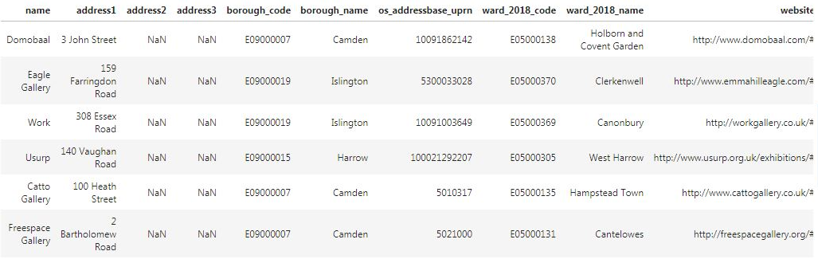

* Post indexes and boroughs of London as well as the latitude and longitude of each borough of London provided by doogal.co.uk . Common geographical data necessary for accurate localization of boroughs in order to visualize our data for further exploration

Link : <https://www.doogal.co.uk/PostcodeDownloads.php>

Format : CSV file

* Foursquare location data and venues information for each borough. This is comprehensive amount of data about various kinds of venues, its location and popularity. I‘m going to use the Foursquare API to explore distribution of different venues for each borough of London

Link : <https://foursquare.com/>

Format : JSON

All *.csv files will be uploaded and placed into the project working directory for ease of use